MNIST Tanh:

Not normalized (images in 0-255):

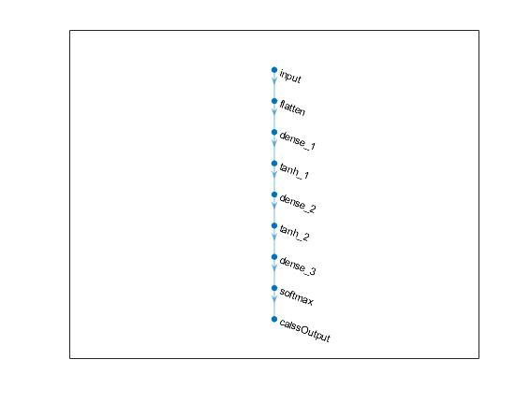

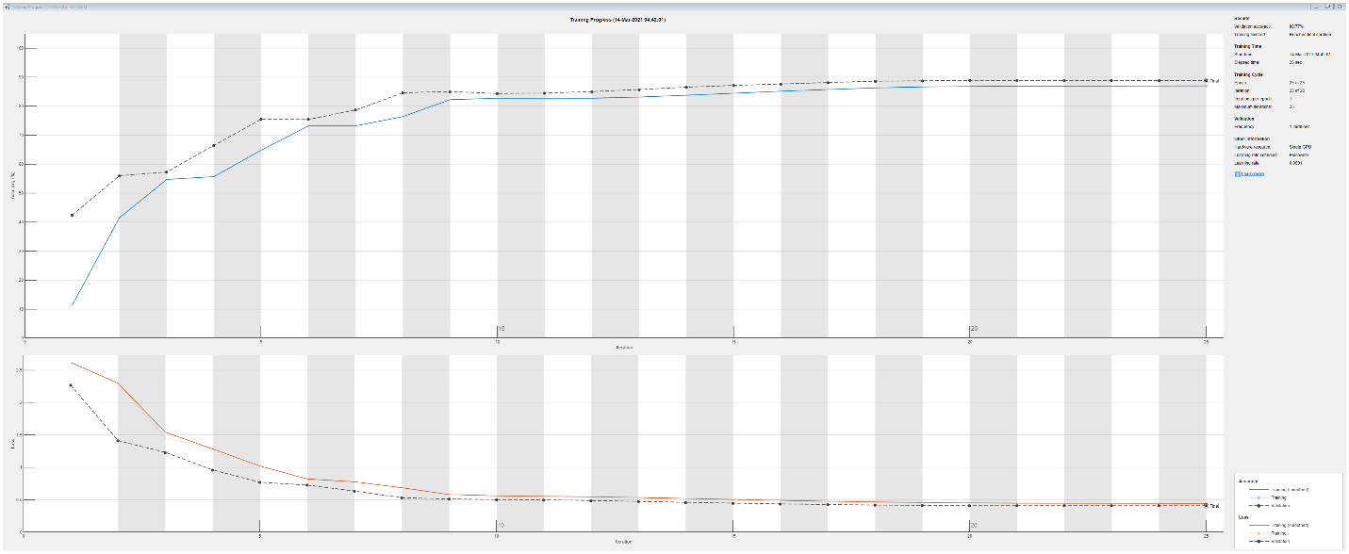

Validation accuracy: 88.77%

Test accuracy = 0.8791

MNIST Tanh:

Normalized (images in 0-1):



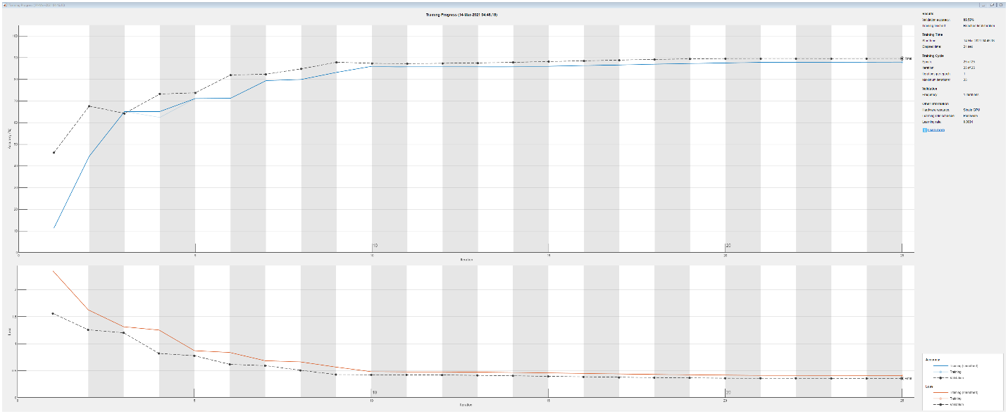

Validation accuracy: 89.58%

Test accuracy = 89.11%

